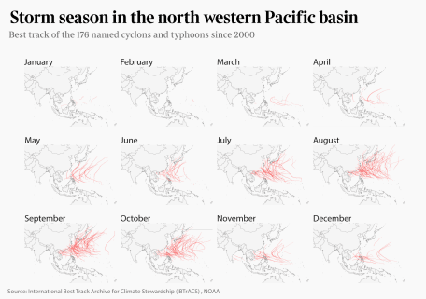

Mapping historical storms data is now a little bit easier. [Off the back of this blog](https://blog.basilesimon.fr/2018/09/05/storms-map-in-R/), I have authored an R package (available at [basilesimon/noaastorms](https://github.com/basilesimon/noaastorms)) that downloads, cleans and parses NOAA IBtrack data for you.

The National Oceanic and Atmospheric Administration releases datasets known as [International Best Track Archive for Climate Stewardship](https://www.ncdc.noaa.gov/ibtracs/).

These datasets are updated regulary and cover all our oceans. The data found in there is fantasticly detailed and goes back as far as 1850 in some case (I wonder how!).

**How to install**

library(devtools)

install_github("basilesimon/noaastorms")

**Available functions**

getStorms: Fetch NOAA historical best track storms data

> df <- getStorms(c('EP'))

> head(df[1:5])

Serial_Num Season Num Basin Sub_basin Name

2 1902276N14266 1902 01 EP MM UNNAMED

3 1902276N14266 1902 01 EP MM UNNAMED

4 1902276N14266 1902 01 EP MM UNNAMED

5 1902276N14266 1902 01 EP MM UNNAMED

6 1902276N14266 1902 01 EP MM UNNAMED

The first argument is a vector of basin codes from this list:

* NA: North Atlantic
* SA: South Atlantic
* NI: North Indian
* SI: South Indian
* EP: East Pacific
* SP: South Pacific
* WP: West Pacific

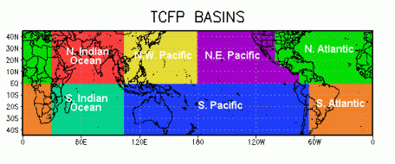

To get storms that took place in the Atlantic for example, run getStorms(c('NA', 'SA')).

The second (optional) argument is a date range to filter data with. For example:

dateRange <- c(as.Date('2010-01-01'), as.Date('2012-12-31'))

getStorms(c('NA', 'SA'), dateRange = dateRange)

Will query storms that took place in the Atlantic in 2010 and 2012.

**Usage**

# load a map of the world and

# use `clipPolys` to avoid issues

# when zooming in with `coord_map`

wm <- map_data("world")

library("PBSmapping")

data.table::setnames(wm, c("X","Y","PID","POS","region","subregion"))

worldmap <- clipPolys(wm,

xlim=c(20,110),ylim=c(0, 45),

keepExtra=TRUE)

# load storms for the Atlantic ocean

spStorms <- getStorms(c('NA', 'SA'))

ggplot(spStorms,

aes(x = Longitude, y = Latitude,

group = Serial_Num)) +

geom_polygon(data = worldmap,

aes(x = X, y = Y, group = PID),

fill = "whitesmoke",

colour = "gray10",

size = 0.2) +

geom_path(alpha = 0.1, size = 0.8,

color = "red") +

coord_map(xlim = c(20,110),

ylim = c(0, 45))

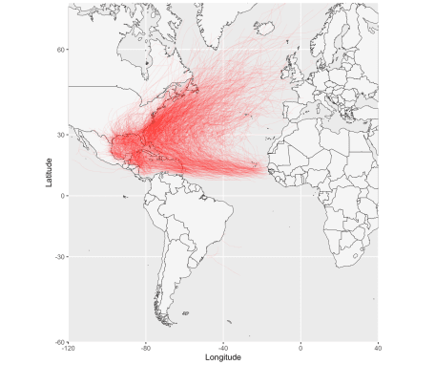

**Your feedback is important**

Next on the list are more complex queries. Sadly, supporting date ranges doesn't change how much data we need to download (the NOAA data is bulk export).